Business Presentations: Essentials

for government officials



Content
1: Structure of a Speech page 3
2: Model Speech 1: Self Introduction page 4
3: Delivery Skills page 6
4: How to say it page 8
5: Logic Tree Notes page 9
6: Introducing the Speaker page 12
7: Model Speech 2: Policy page 13



1: Structure of a Speech
- Speeches have three important parts. Each part has a specific purpose.

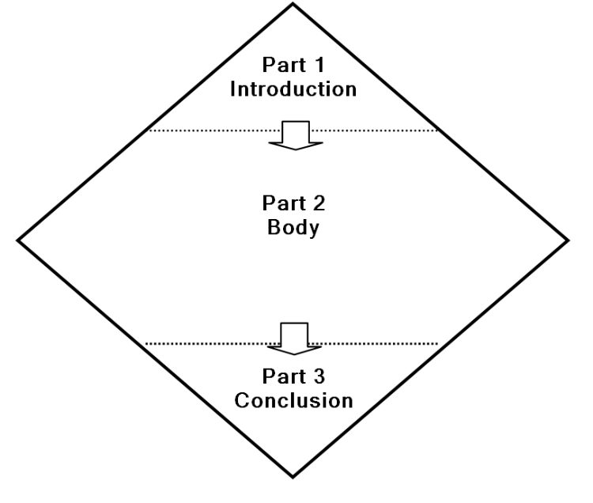

Part 1 – Introduction: Say what you are going to say.
This is the foundation of your speech.
- Greet your audience. Introduce your theme and your main points.
- Get your audience interested!
Part 2 – Body: Say what you want to say.
This is the main part of your speech.
- Tell your audience everything you want them to know.
- You must select what you say: you cannot say everything about your theme – just the most important ideas linked to your message.
- Keep your audience interested!
Part 3 – Conclusion: Say what you said. Deliver your message.
This is the wrap up – make a strong finish.
- Review your theme and your main points.
- Do not introduce any new ideas or new information.
Deliver your message clearly: it is a vital part of your conclusion.
- Tell your audience what you think and what you want them to do.
- Leave your audience thinking about your message!

2: Model Speech 1: Self Introduction
- Model Self-Introductory Speech
Below is a model self-introductory speech. It is very short however, it follows the basic speech structure of introduction, body, and conclusion. Read the speech carefully.

Background: Hiroshi Tanaka works for the Japan Marine Security Agency in Tokyo. Below is the self-introductory speech he gave at a training program.

Notes | Text
1. Introduction  - Greetings & courtesies | Thank you, Mr. / Ms (Chairperson’s name). Good afternoon everyone. It’s a pleasure to be here. As Mr. / Ms (Chairperson’s name) said, my name is Hiroshi Tanaka. I’d like to tell you a little about myself and my work at the Japan Marine Security Agency.
2. Body  - My background, interests & comments | I was born in Hokkaido but I grew up and went to school in Kyoto. In high school I liked world history and geography and belonged to the International Club. I also enjoyed playing sports on the school teams. I really liked playing volleyball. Our team was quite good and we won several local tournaments.
- My work at JMSA | At university I studied international affairs and had an interest in security. I found it very interesting and wanted to do some kind of international work. My advisor at university suggested I apply to Japan Marine Security Agency. I passed the exams and the interviews and was offered a job. I was very happy.
- General statement  - My work at JMSA  - Thinking about my future | So far I have worked in two bureaus at JMSA. First, I worked in the General Affairs Bureau and now I am working in the Research Bureau. My current work is very interesting and I am really enjoying it. I am looking forward to attending conferences overseas and possibly working in a foreign country in a couple of years.
3. Conclusion  - Courtesies  - Closing courtesy | I am very happy to be here today and I am glad to be working with you all.  Thank you very much.

- Exercise
Use the model above to write a short speech to introduce yourself and your work. Write your speech on the next page or write it on your computer and print it out.
Length: 90 seconds.

- Your Self-Introductory Speech

3: Delivery Skills
- Good delivery skills are essential for a good presentation.
Good delivery skills build your confidence and win the attention of your audience.
- Your teacher will model each of these skills for you one-by-one.
- Stand up and practice the skills with your teacher until they are easy to do.

Eye Contact
Voice
Clothing
Gestures
Notes
Posture

Speak to your audience. Deliver your message.

- Voice
Your voice is your most important delivery tool.
A clear strong voice delivers your message to your audience. If they cannot hear you they will not receive your message.
- Speak clearly, smoothly, and without hesitation.
- Don't rush or speak too quickly.
Emphasize the important words and phrases.
- Eliminate the pauses and Ummmms.
- Eye Contact
Eye contact connects the speaker and the audience.
- Look at your audience, not at your notes.
- Look at the whole audience. Move your head so you can make eye contact with everyone.
- Notes
Hold your notes just above your waist where you can easily see them and look at your audience.
- Hold the page in the middle so it won’t fold over.
- Don’t move your notes up and down: it’s very distracting.
- Don't put your notes on a table or lectern – If you're looking down at your notes, you can't look at your audience.
- Posture
Good posture helps your breathing and makes you appear more confident.
- Stand straight with your feet slightly apart and your weight evenly on both feet.
- Don't lean on the table or lectern – look at your audience.
- Gestures
There are three positions for your other hand: by your side, behind your back, or gesturing.
Gesturing is the best thing to do with your free hand:
- Gestures attract your audience’s attention and emphasize important points.
- Gestures should be simple, firm and clear.
- Gestures and eye contact go together. When you gesture, look at your audience: If you are not looking at your audience, do not gesture.
- When you count (1st, 2nd, 3rd), gesture with one finger, two fingers, three fingers.
- Don’t count with your fingers if you say, "My next point is…" or "My last point is…"
- Don't scratch your face or play with your hair!
- Don’t cover your face with your hand if you adjust your glasses.
- Clothing – Neatness counts!
Make sure your clothing is appropriate for the situation and then wear it neatly.
- Messy clothing and hair will distract your audience from your message.
- Before you speak make sure your clothing is neat: check your tie, your jacket collar, and your hair.
- Tips for Effective Speaking
- Starting Your Speech
Your speech begins when you are called to speak.
Before you speak, pause, look at your audience, and get their attention. Take a deep breath and begin.
- Speak to Your Audience
If you memorize parts of your speech, you can look at your audience. Memorize –
- your greetings
- your introduction
- the beginning of each main point
- your conclusion and closing thoughts
- Speak Clearly and with Passion
Let your audience know that you care about your topic: Speak with energy and enthusiasm in your voice.
- Emphasize important words with your voice and with gestures.
- Pause slightly before and after names, dates, numbers, and important words.
For example: “In^2012,^Protech^sold^187,000 units of ^PX-Y40.”

4: How to say it
- Flag Expressions
 | - Flag Expressions are special expressions that introduce each step in the structure of your speech.  - Flag Expressions are like a tour guide’s flag: everyone can follow the guide’s flag and not get lost. If there is no flag the guide is too hard to follow.
- Memorize and use the Flag Expressions. They will help you organize your information and ideas, and express yourself clearly.

Part | Purpose | Flag Expressions
1  Introduction | - Appreciate the introduction | Thank you for the introduction, (Mr. Chairman).
 | - Greet the audience | Good evening, everybody.
 | - Give your theme | Today, I am going to tell you about …
 | - Give your main points | I have three main points.
 |  | First, |  | (Never say At first)
 |  | Second, |  | I will talk about…
 |  | Third,
2  Body | - Start the body | Let me begin with my first point.
 | - Second point | Now, I’ll move on to my second point.
 | - Third point | Now, I will tell you my third point.
3  Conclusion | - Review | In conclusion, let me review my main points.
 |  |  | First,
 |  |  | Then, |  | I talked about….
 |  |  | Finally,
 | - Your Message | I think that… (*Never begin with Let’s…)  Thank you. (*Never say That’s all.)  And now, I will be happy to answer your questions.
 | - Close

5: Logic Tree Notes
- What is a Logic Tree?
When you make notes for your speech, use a logic tree.
A Logic Tree is like a chart. It is an easy way to organize and remember your ideas because it has a place for each part of your speech: the theme, main points, details for each point, and your message.

- Why is your speech like a tree?
Can you name the parts of the tree?






Roots | The roots of your speech are your preparation.  - Strong roots make a strong tree.  - Good preparation makes a good presentation.
Trunk | The trunk is the theme or main idea of your speech.  - Everything in your speech must be connected to the theme.
Branches | The branches are your main points. Three is a good number.  - All your main points must come from the theme.
Leaves | The leaves are your details, numbers, and examples.  - They explain your main points and make your speech interesting.
Fruit | The tree’s fruit is your message.  - Your message is what you want your audience to take away and think about.  - Without a clear message your speech has no purpose.

- Logic Tree Sample 1
Below is a Logic Tree for speech notes: the theme is on the left, followed by the main points and supporting details; finally, the message is on the right. Extra lines can be added if needed.
The Logic Tree is a very useful tool. By writing your speech notes in this pattern, it is easy to organize your ideas and information. Your speech will be complete and you won’t forget anything. With your notes in a Logic Tree, it will be easy to visualize and remember your whole speech from beginning to end.

Parts of a Logic Tree
Trunk | Branches | Leaves | Fruit

 |  |  |  | Supporting Detail 1 for Point 1 |  | Message
 |  |  | 1st Main Point | Supporting Detail 2 for Point 1
 |  |  |  | Supporting Detail 3 for Point 1
 |  |  |  | Supporting Detail 1 for Point 2
Theme |  |  | 2nd Main Point | Supporting Detail 2 for Point 2
 |  |  |  | Supporting Detail 3 for Point 2
 |  |  |  | Supporting Detail 1 for Point 3
 |  |  | 3rd Main Point | Supporting Detail 2 for Point 3
 |  |  |  | Supporting Detail 3 for Point 3

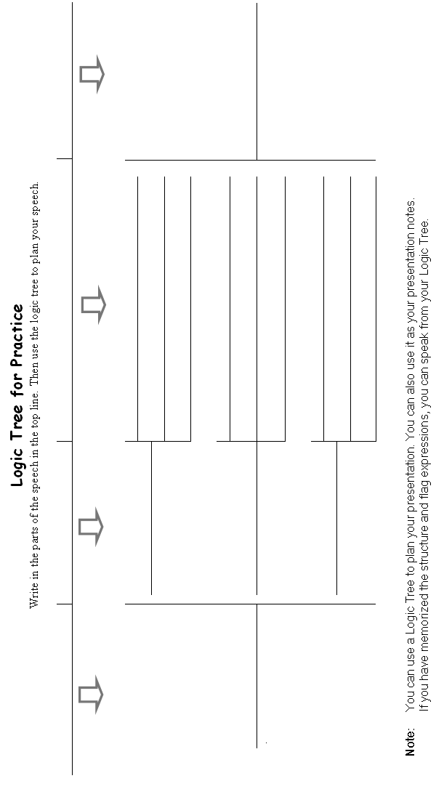

6: Introducing the Speaker

- Important expressions for introducing a speaker.
Introduction
- Good afternoon, everyone.
- It’s my pleasure to introduce our first (next / last) speaker.
- Her (His) name is Mio Tanaka.
- Please give her (him) a warm welcome.
- Ms Tanaka, if you please.

After the speech – Q&A
- Thank you very much, Ms Tanaka.
- Now, we have time for questions.
- Yes, Mr. Oe?
- Are there any more questions?
- We have time for one more question.
- I’m sorry that’s all the time we have for questions.

After the Q&A – close
- Thank you everyone for your questions.
- Thank you very much, Ms Tanaka. That was a very interesting talk.
- Please give Ms Tanaka a big hand. (applause)
- And now, I’d like to ask our next chairperson to take over. Mr. Sueda, if you please.

7: Model Speech 2: Policy
One of the purposes of giving a speech can be to explain policy and express an opinion and thereby influence how others think about an issue. Below is a speech explaining the Japanese government’s ‘Cool Biz’ initiative.
Read the speech and take note of the structure and the language.

Speech Text | Notes
Good afternoon everyone, and thank you for the opportunity to speak to you. I’m here today to talk to you about Cool Biz, an initiative of the Japanese government that has changed modern Japanese society. First I’ll explain why and how Cool Biz was introduced, and then I’ll move onto its impact on Japanese society. I’ll finish by briefly discussing new initiatives that are based on the success of Cool Biz. If you have any questions, I’ll be happy to answer them at the end of my presentation.  So let’s begin with my first point – why and how Cool Biz came into effect. Many people ascribe Cool Biz as being the brainchild of the then-popular Prime Minister, Junichiro Koizumi. However, it was actually Ms Yuriko Koike’s idea. In 2005, Ms Koike was the Minister of the Environment. In order to reduce electricity consumption, and thereby reduce carbon pollution, she proposed the Cool Biz initiative for government offices. The basic concept is that air conditioners should be set to 28 degrees Celsius. This then reduces the amount of energy that air conditioners would otherwise use to sustain cooler temperatures. To compensate for the increased office temperature, employees were encouraged to wear cooler clothes. The initiative quickly crossed from the public sector to the private sector. Initially, the Cool Biz period was from June to September, but in 2011 it was extended to May to October to help Japan deal with its energy needs resulting from the 2011 Tohoku earthquake.  Now, I’d like to talk about my second point – the effects of Cool Biz. In 2005 the Ministry of Energy conducted a survey that showed 95.8% of survey participants were aware of the Cool Biz campaign, and that almost a third of them had already changed their air conditioners to 28 degrees Celsius. The Ministry then projected that the Cool Biz initiative resulted in a reduction of carbon dioxide emissions of 1.14 million tons in 2006. In 2009, another survey indicated that 57% had increased their settings on their air conditioners. However, the impact was not just environmental – it also had a significant impact on the economy. An analysis by the Ministry of Economy, Trade and Industry in 2005 showed an increase in the demand for clothing to the value of 100 billion yen.  Now I’d like to move onto my last point – new initiatives which are connected to Cool Biz. In 2011, after the Tohoku earthquake, the government introduced Super Cool Biz which encouraged the dimming or turning off of lights and the opening of windows and turning off air conditioners completely. In return, an even looser dress code of polo shirts, Hawaiian shirts and casual shoes was encouraged. Now, the Ministry of Environment’s website promotes ‘Cool Share’ whereby people are encouraged to reduce electricity further by being together in a cool air conditioned place, and turning off all other air conditioners in the home, instead of being apart in separately cooled rooms. Also, the department store chain Ito Yokado is promoting a campaign called ‘Cool Choice’ where people make buying choices that result in reduced electricity consumption. One example given is buying trousers and rolling them up 5 cm from the bottom to allow for cool ankles!  In conclusion, Cool Biz has become a standard part of Japanese summer culture. People look forward to not having to wear a tie and jacket in the summer heat. New initiatives continue to pop-up and encourage consumers to buy seasonally appropriate clothing, showing just how much of an economic impact the initiative has had. I think Cool Biz is great for Japan, both economically and environmentally, and the government should continue to actively promote it. Thank you very much for listening. Now, I’ll be happy to answer any questions you may have. | - Introduction : Greetings & courtesies  Introduce the theme and main point.  - Body: 1st point  Body: 2nd point  Body: 3rd point  - Conclusion: Summarize and give a clear message  Closing courtesies



Business Presentations: Essentials
for government officials

Prepared by David Dobson and Kenneth Goldstone

With the assistance of B Allan

March 2014

Revised July & October 2014,

February 2015, June 2015,

January 2017

This Edition July 2017

Avanti Staff, Language Service Dept.

Tokyo, Japan



